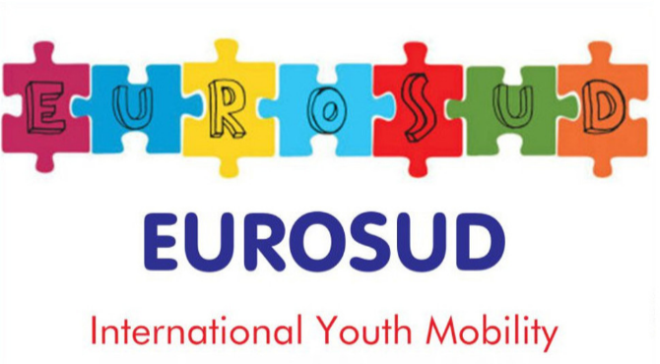

PARTICIPANT APPLICATION FORM

INTERNATIONAL ERASMUS+ EXCHANGE
„SOUNDMAPA OF EUROPE II”
KAMIEŃ, POLAND
ARRIVAL DAY 18TH AUGUST DEPARTURE DAY 29TH

Part I
READ HERE PROJECT INFOPACK
A. Personal details
Name :
Surname:
Gender (M / F ):
Age:
Date of birth:
City and country of birth:
Passport OR Carta ID elettronica valida espatrio
Profession / occupation:
Special needs (e.g. food, disability, others, please specify):
B. Contact details
City Address:
E-mail:
Mobile telephone:
Facebook/twitter link(optional):

Part II
What is your personal / professional experience in relation to the theme of the project?
What previous Council of Europe, Youth in Action, Erasmus + or any other international youth work activities have you attended? Please specify the name and the dates of the activities.
What is your motivation to participate in this project and how your ORGANIZATION will benefit from participation in this project? In case you are not part of any organization, please explain how you will PERSONALLY benefit from this experience
During the project, you are going to have the opportunity to deliver a session/ workshop related to the main topic. What it would be ?Please explain here briefly:

Prove us you are not a robot. How much is 2+3? *

Please write your possible travel itinerary
Date | Kind of transport | From*  Place and time | To*  Place and time | Price
*Please indicate departure/arrival place and time (e.g. Rome (21:30)- Istanbul (23:30))

Submit to your sending organization!

EUROSUD (947611625) ITALY
eurosudngo@gmail.com

Compilando questa candidatura autorizzo al trattamento dei miei dati personali ai sensi del Decreto Legislativo 30 giugno 2003, n. 196 “Codice in materia di protezione dei dati personali” e del GDPR (Regolamento UE 2016/679)

This travel itinerary is just indicative. Please do NOT buy any ticket before approval of your sending organization.

